How to access the BMFA Registration Competancy Test
Open BMFA Home page ( can be done through our website by clicking on the BMFA Logo)
Then Click onto “Click Here To Take the BMFA Registration Competancy Test”
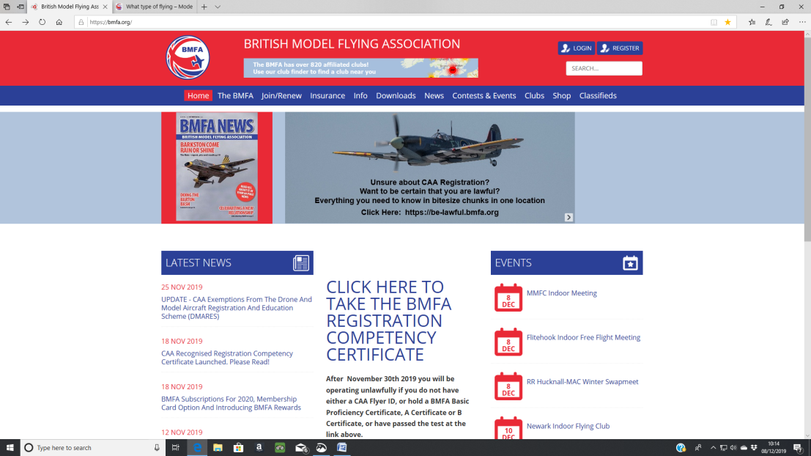
The next page opens as shown below.
You can then do the test by clicking on “Click Here to take the Test” or Click on the other 2 options to access more information about the rules and regulations.
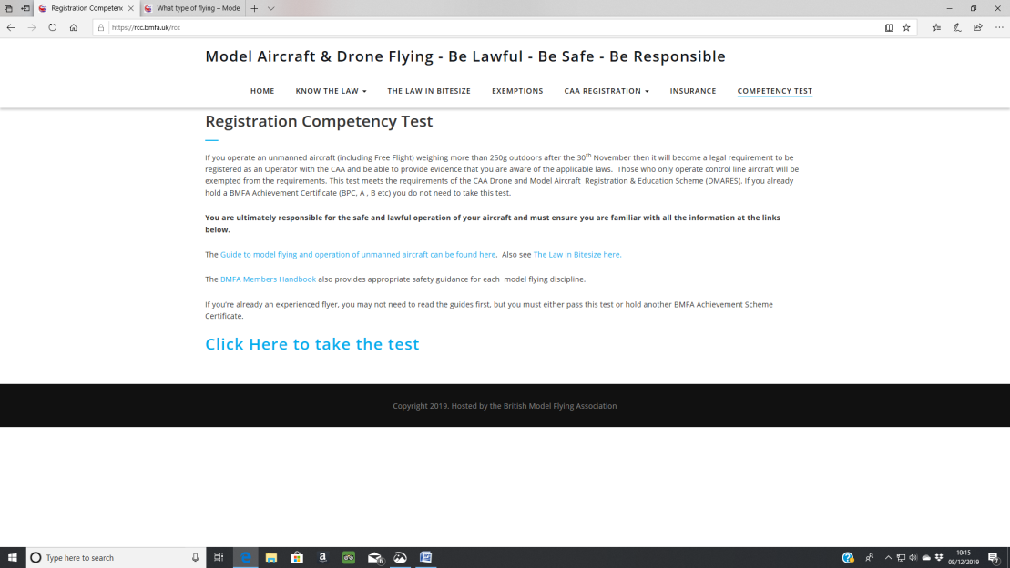

The next screen is as shown below, select “Yes” that you are a current BMFA member and “No” if you do not use a camera.
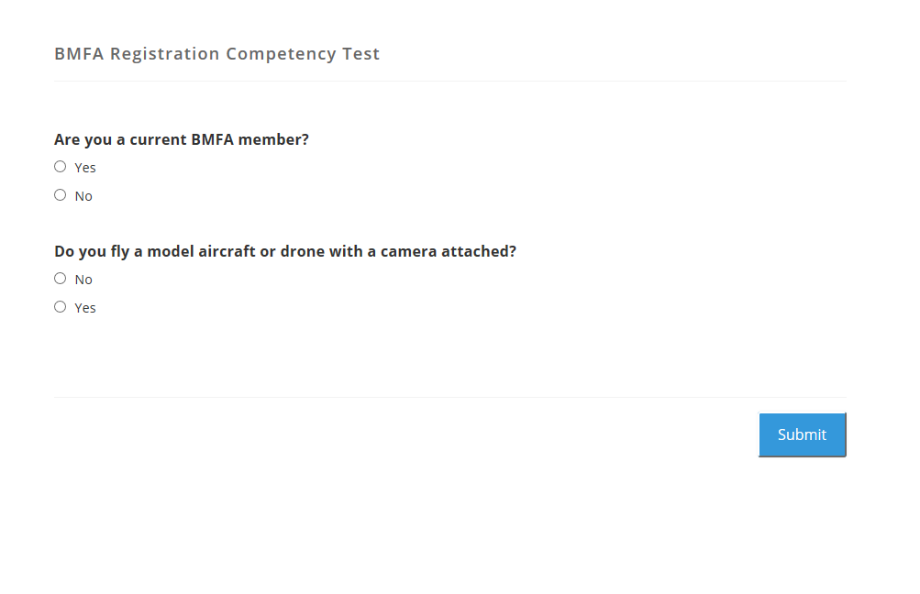
Click submit and you will be taken to the correct Test.
You do not have to achieve 100% and at the end of the Test any incorrect answers are shown with the correct answer given.
You can take the Test as many times as you wish but the Test is fairly straight forward.
After completing the test successfully your Certificate will be shown on the screen, you should save this as a file then log onto the BMFA by going to the Home Page and Clicking Register. You will be taken to the page shown below.
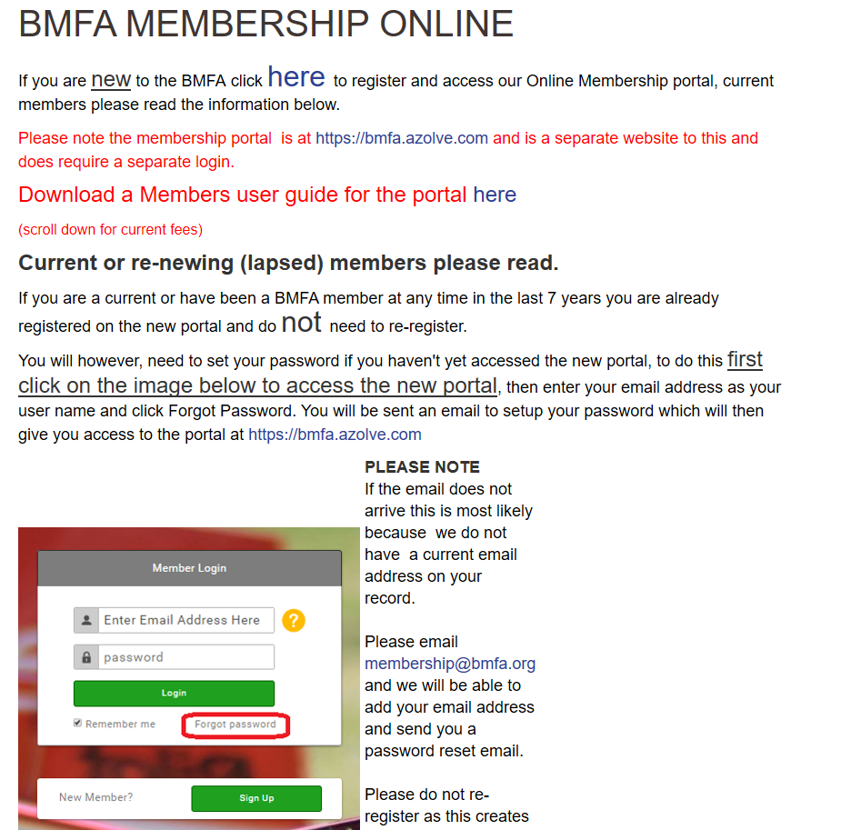

If you have never logged on before, enter your Email Address and create your own password. (you will do this every time in the future to access or update your personal details).
You will then be taken to your own details.
Click on the word “Achievements” on the left hand side then click on “Add Achievements”.
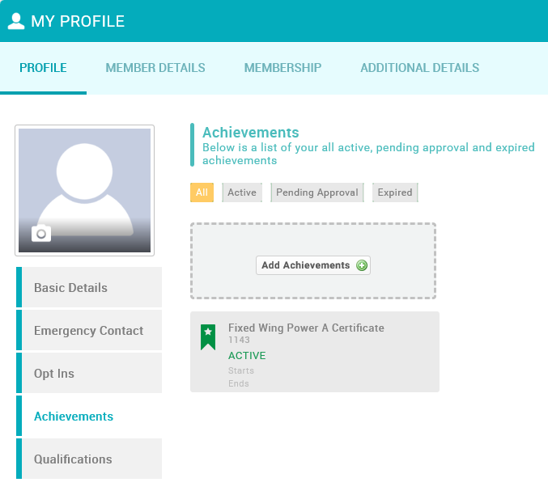
Select as the RCC as shown below.
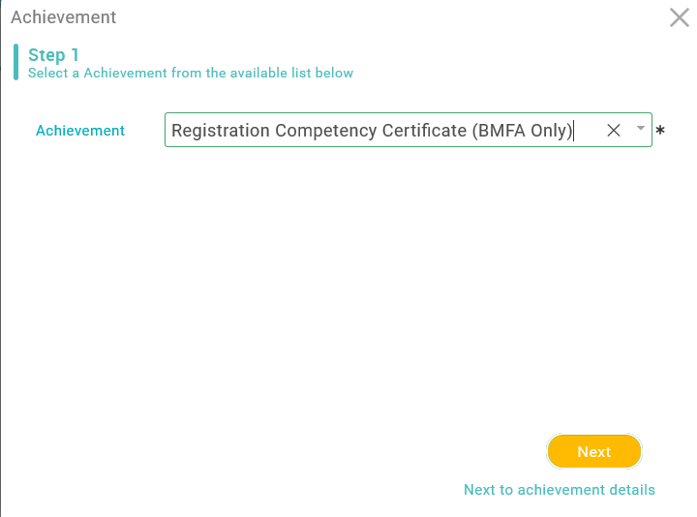
Enter “BMFA” in the Examiner Box and the current Date in the Start Date, then click next.
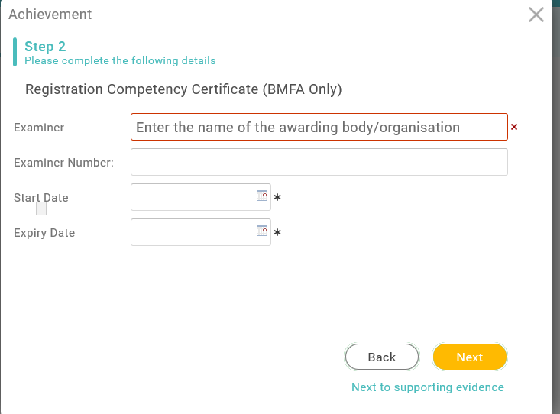

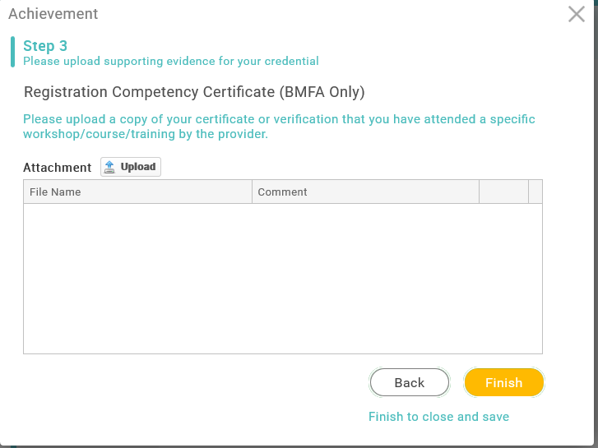
Locate the Certificate File you have saved and upload it.
Then click Finish and your RCC certificate should appear on your achievements screen.

